MOBILE APPLICATION DEVELOPMENT
WEEK 1
Objective: To set up mobile development environment and create a simple flutter application.
Activities completed.
- Installed Android Studio.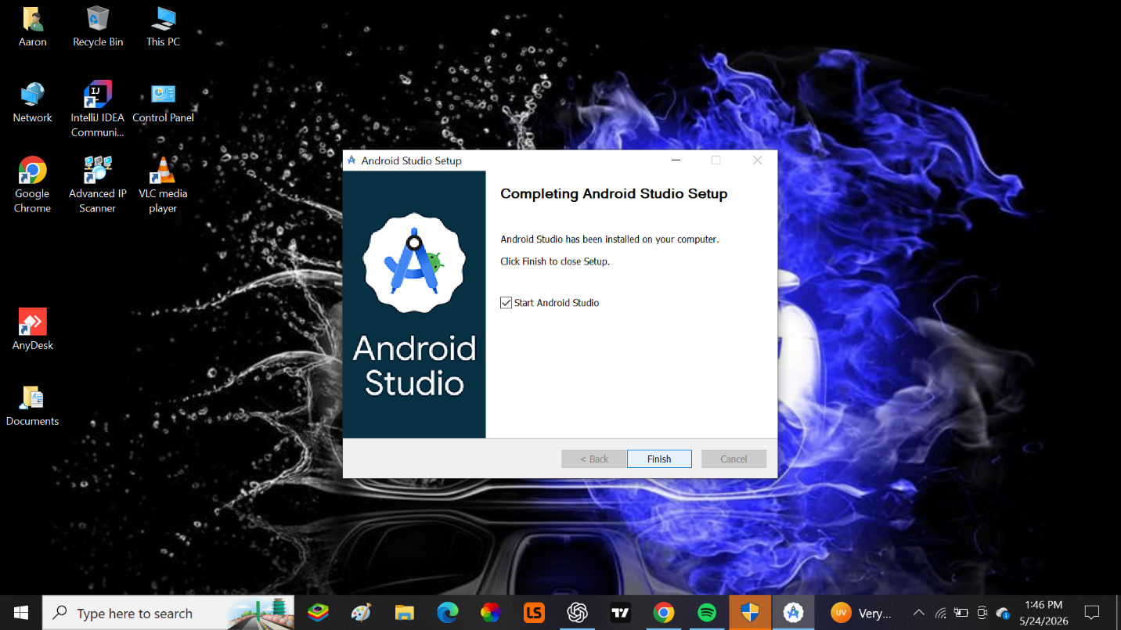
- Configured Android SDK and Emulator and Verified development environment.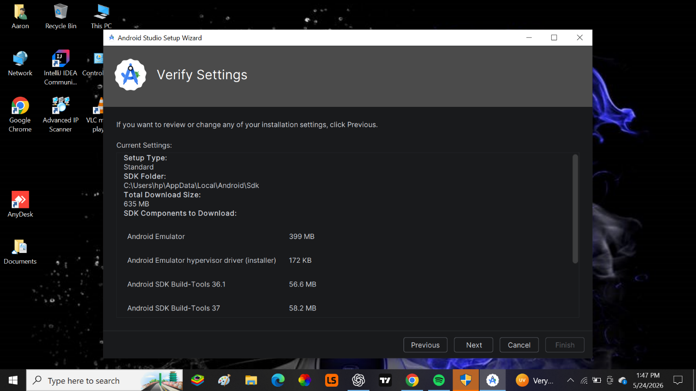
- Created a new flutter project.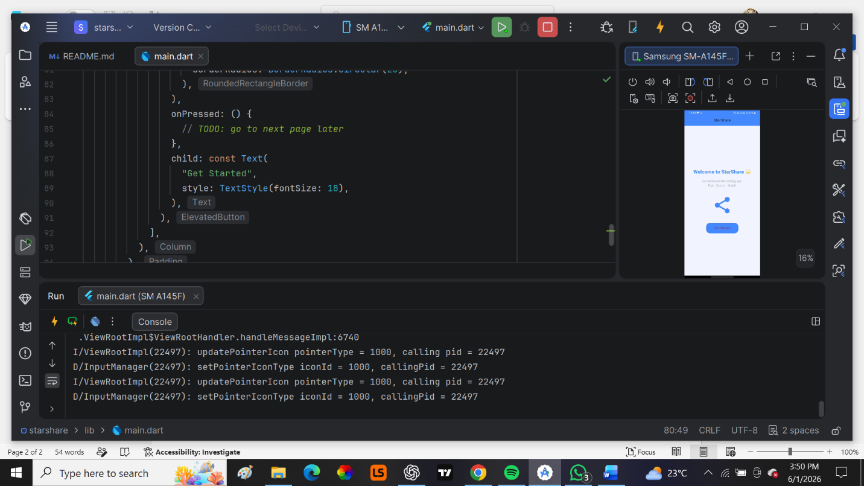

- Modified the application title, changed the background colour and adjusted the font size of the application text.
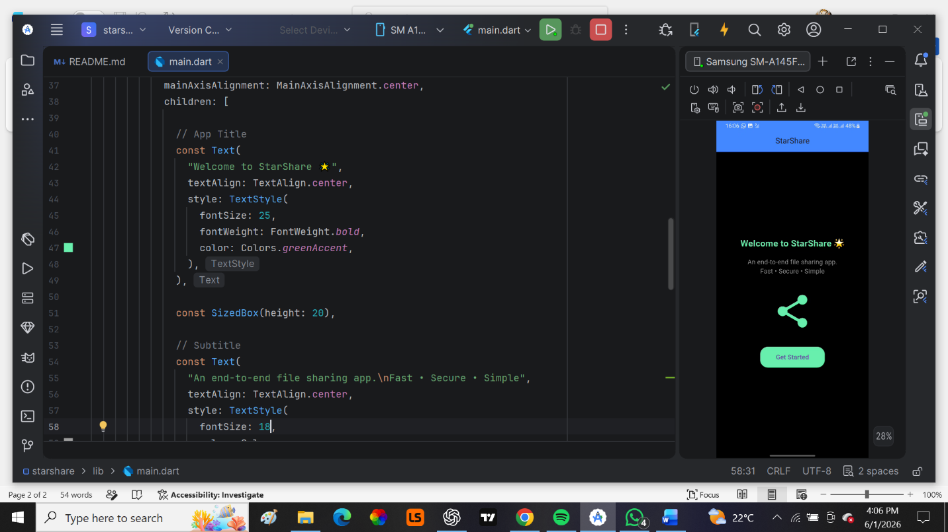
Tools used:
- Android Studio
- Flutter SDK
- Android Emulator
Reflection:
This week provided practical experience in preparing a complete mobile development environment. I gained better understanding of Android Studio, Flutter SDK installation, emulator configuration, and application execution.

Objective: To create wireframes in Figma to represent the structure of application screens.
Figure 1: Onboarding Screen Wireframe.
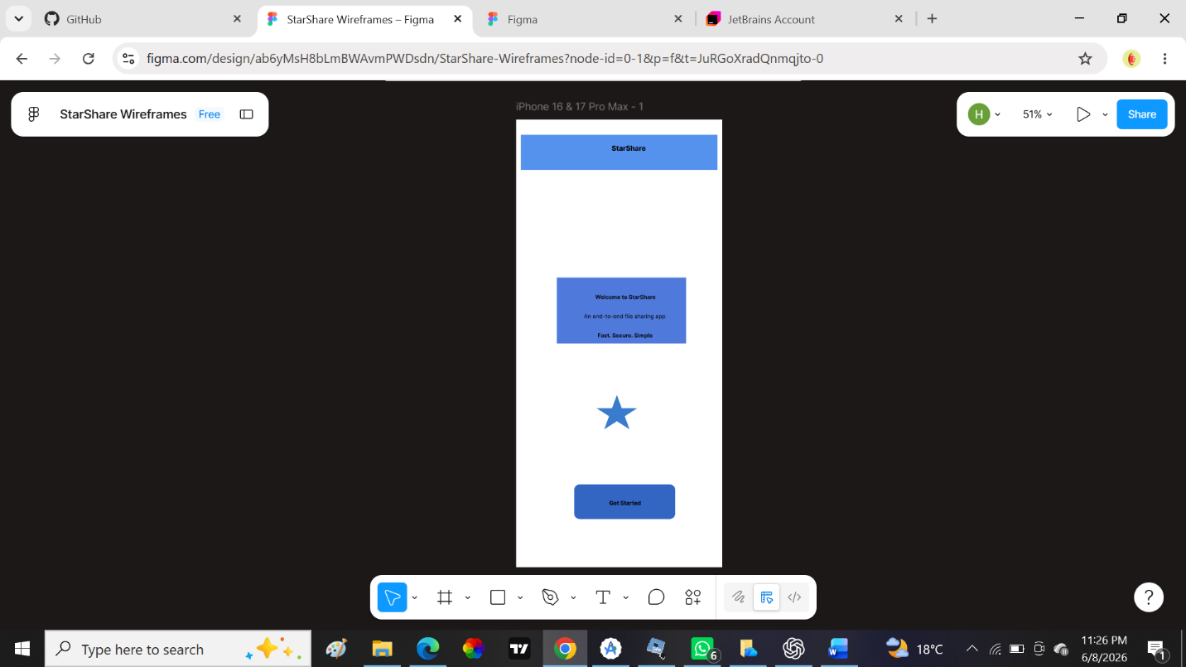
Figure 2: Splash Screen Wireframe. 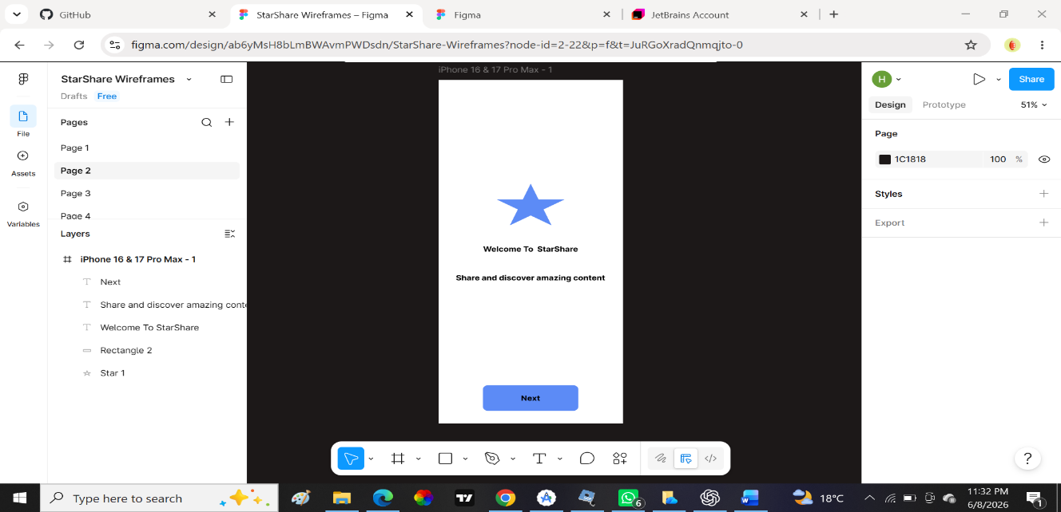

Figure 3: Login screen Wireframe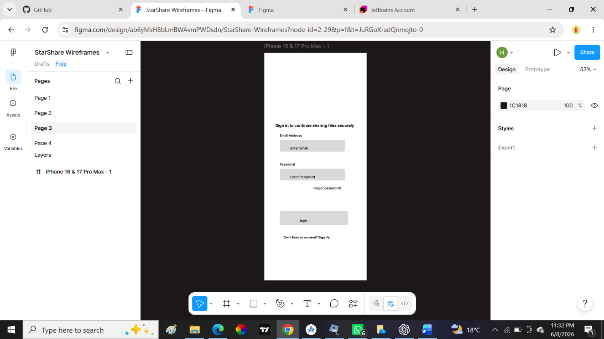
Figure 4: Home Screen Wireframe
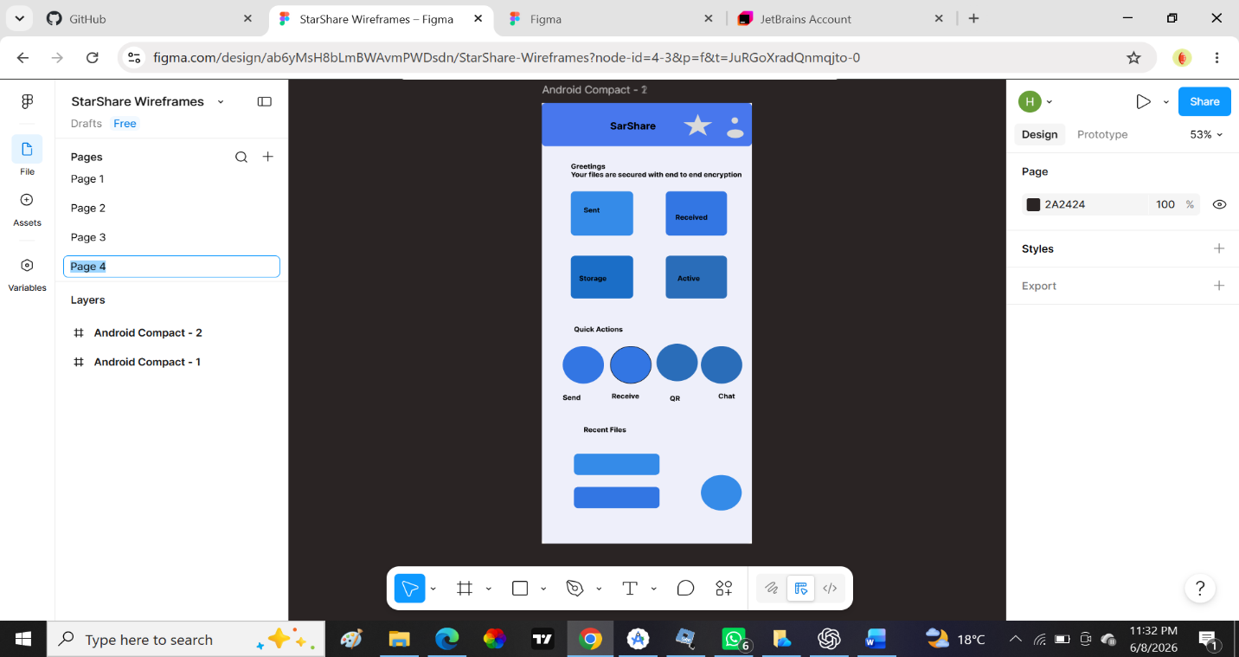
Tools used include:
- Figma (for wireframing and UI design)
Week 4: Event Handling and User Interaction
Practical Activities Undertaken
- Implemented button click events in Flutter UI.
- Added navigation between screens using routes.
- Implemented form validation for login and registration.
- Handled user inputs using TextEditingController.
- Added loading indicators during user interactions.
- Implemented basic error handling for invalid inputs.
Figure1
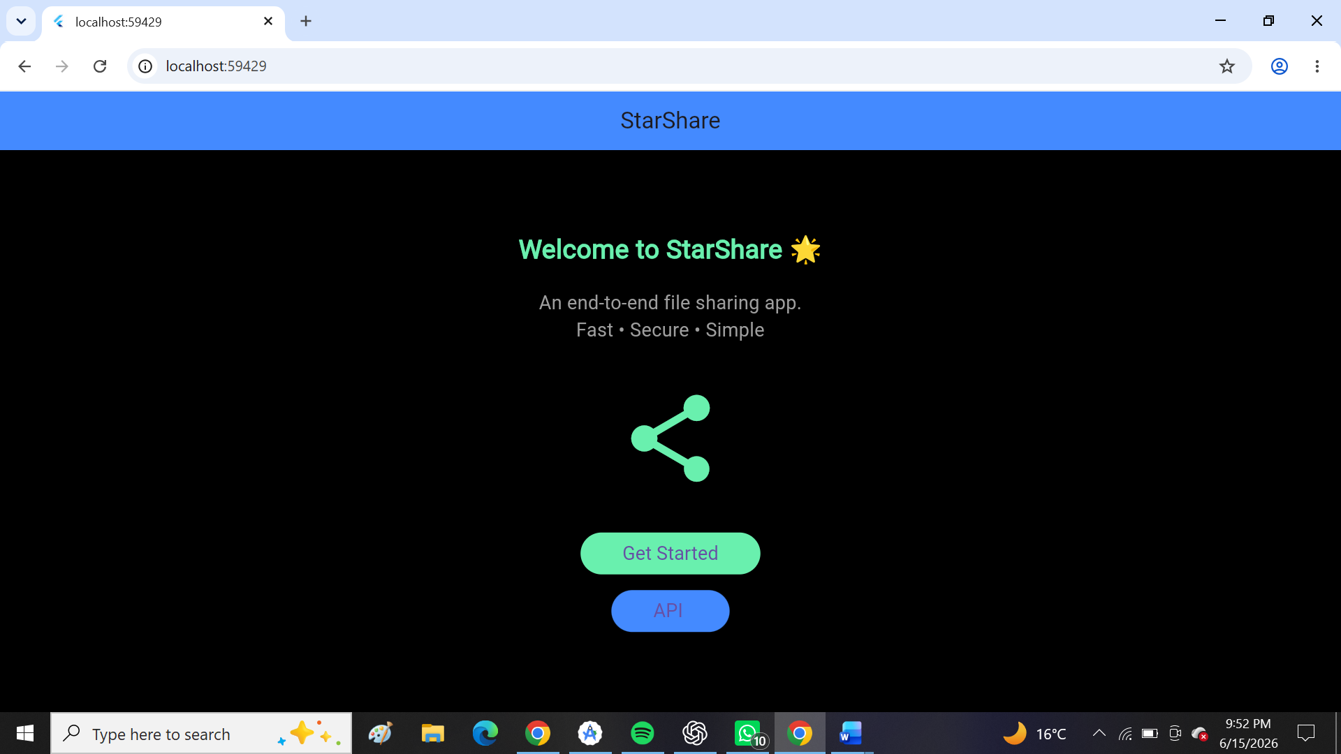
The get started button leads you to onboarding page.
Figure 2
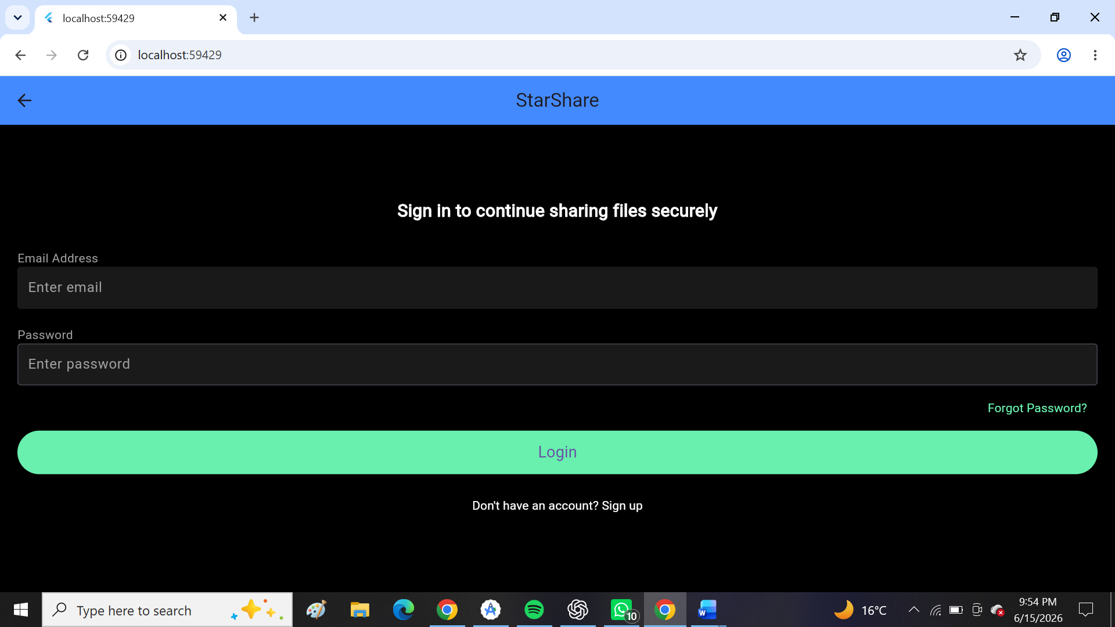
The login button takes you to home page.

Tools used:
- Flutter SDK
- Android Studio
- Dart Programming Language

Personal Reflection
I learned how to handle user interactions in Flutter using event listeners, navigation, and form validation. This improved the responsiveness and usability of the application.

Week 5: Data Management
Practical Activities Undertaken
- Created data models for users and posts.
- Implemented local state management using setState().
- Integrated API service for data fetching and posting.
- Parsed JSON responses from backend.
- Displayed dynamic data using ListView.builder.
- Handled loading and error states in data rendering.
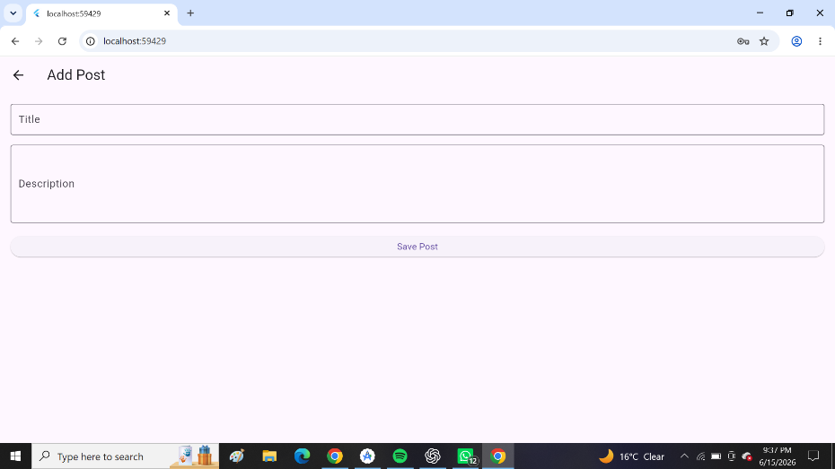
Allows adding and saving of posts
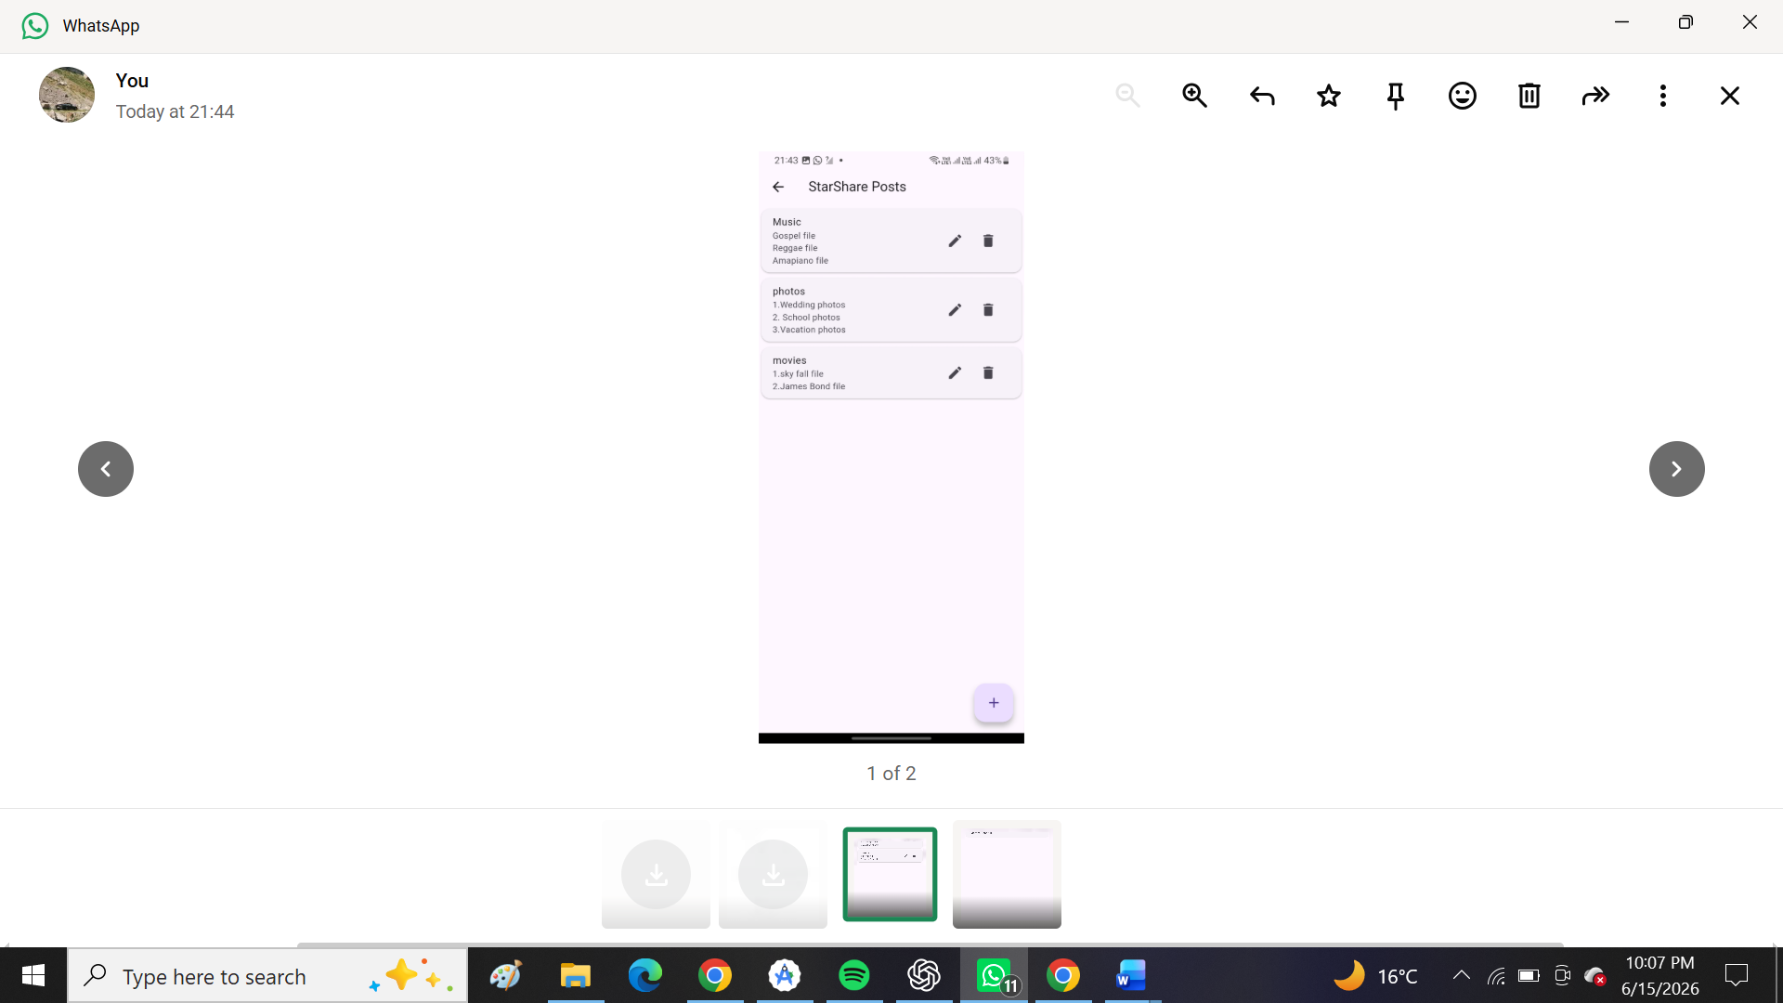
This one shows the editing and the deleting part of the system.
Tools Used
- Flutter SDK
- Dart
- API Service (HTTP package)
- Android Studio
Personal Reflection
I gained practical experience in managing and displaying dynamic data in Flutter applications. I also learned how to integrate backend APIs and handle JSON data effectively.

Week 6: Networking and APIs
Practical Activities Undertaken
- Created REST API service for backend communication.
- Implemented HTTP GET and POST requests in Flutter.
- Connected Flutter application to backend server.
- Handled API responses and errors.
- Implemented asynchronous programming using async/await.
- Tested network connectivity and data flow.
Figure1
This one shows a button for API for backend communication.
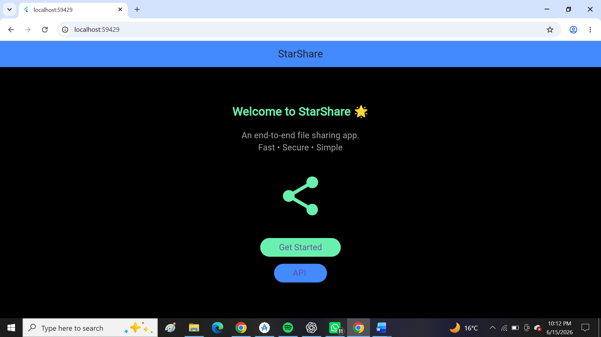

Figure 2
This shows when the internet access is denied, the server cannot be reached.
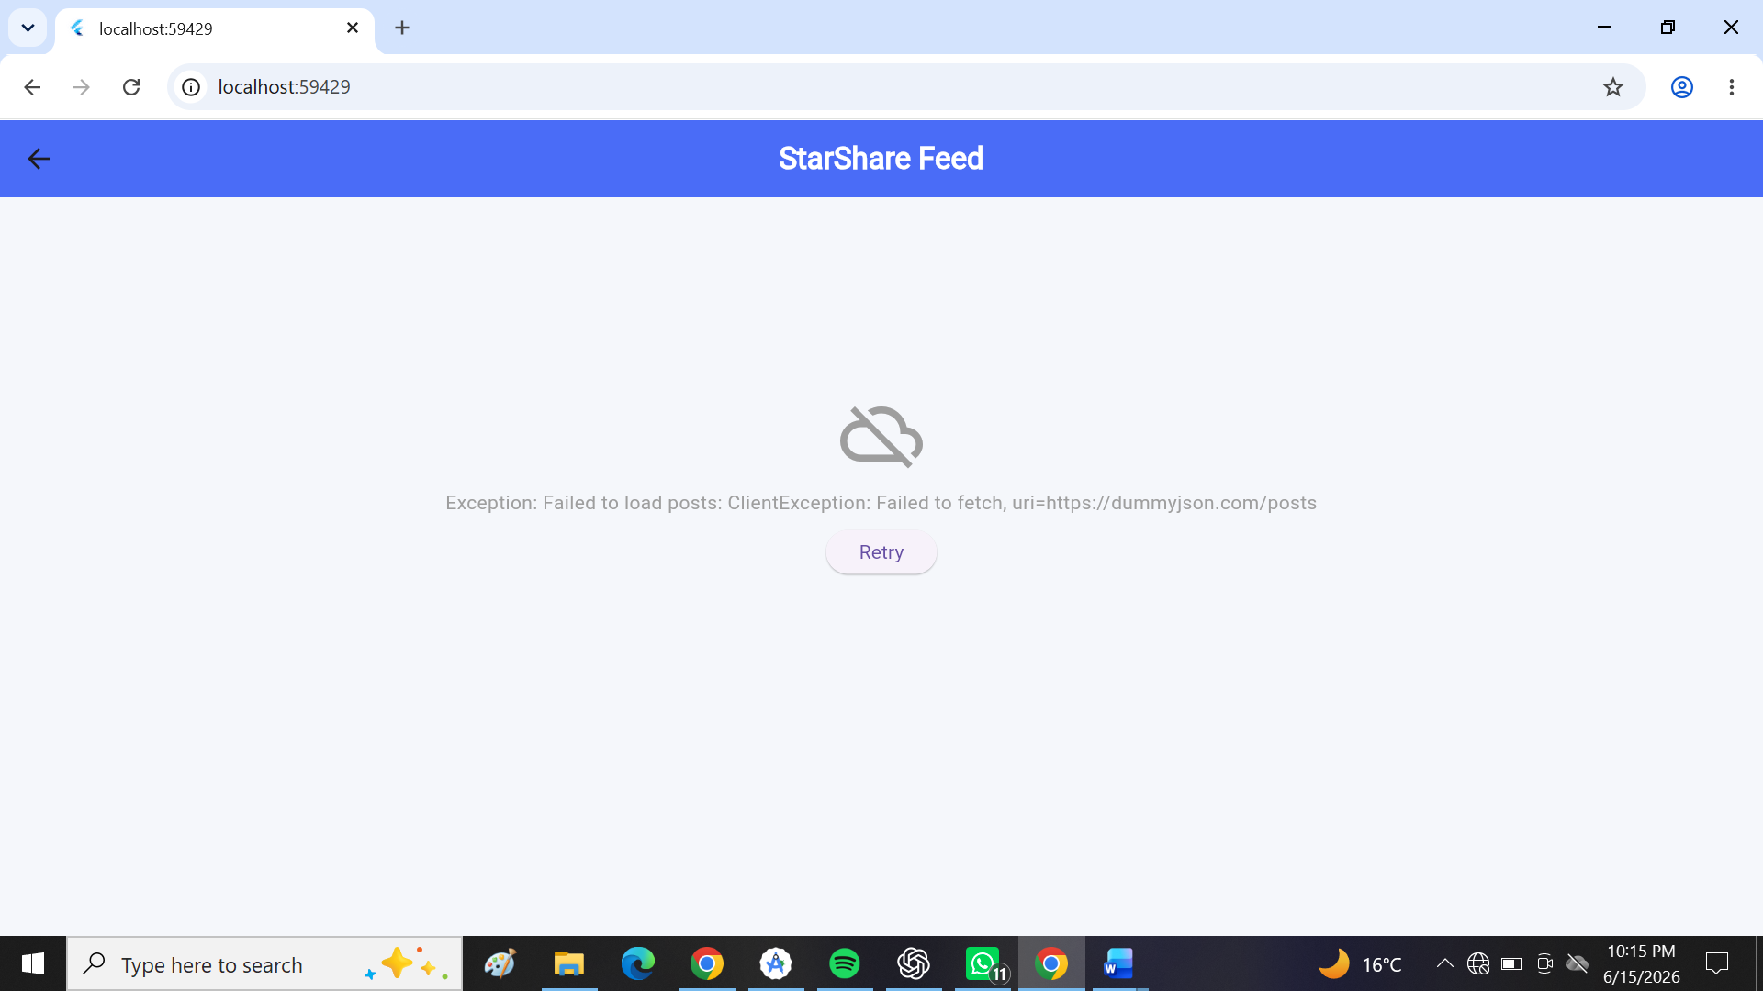
Figure 3
- Handled API responses and the internet error and reached the information.

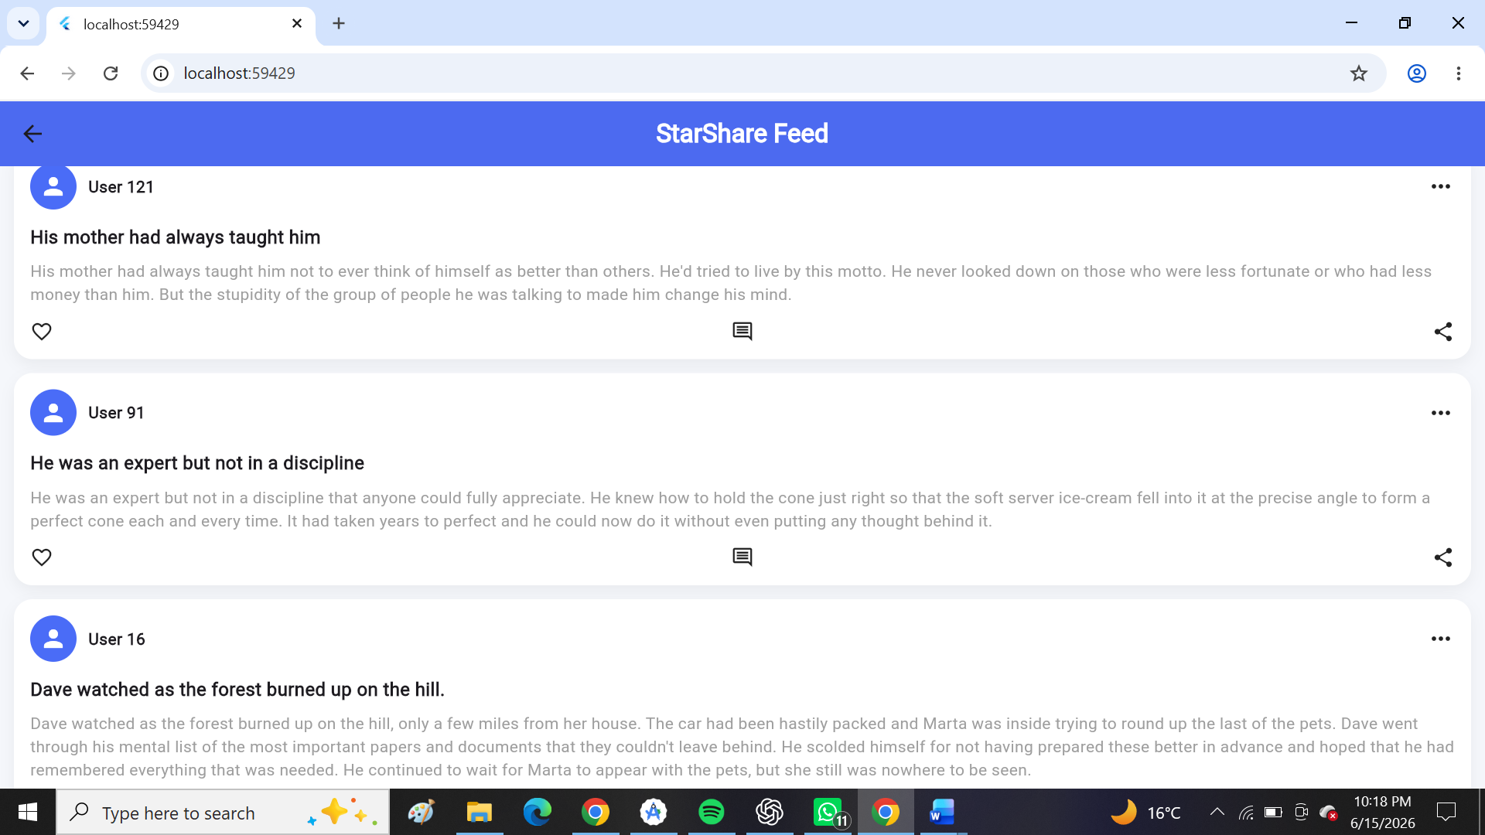
Tools
- Flutter SDK
- Dart
- HTTP package
- Backend API (Node.js / PHP / Firebase if used)
- Android Studio
Personal Reflection
I learned how to connect a mobile application to external APIs and manage real-time data exchange. This improved my understanding of networking, asynchronous programming, and backend integration.
The network connection string code
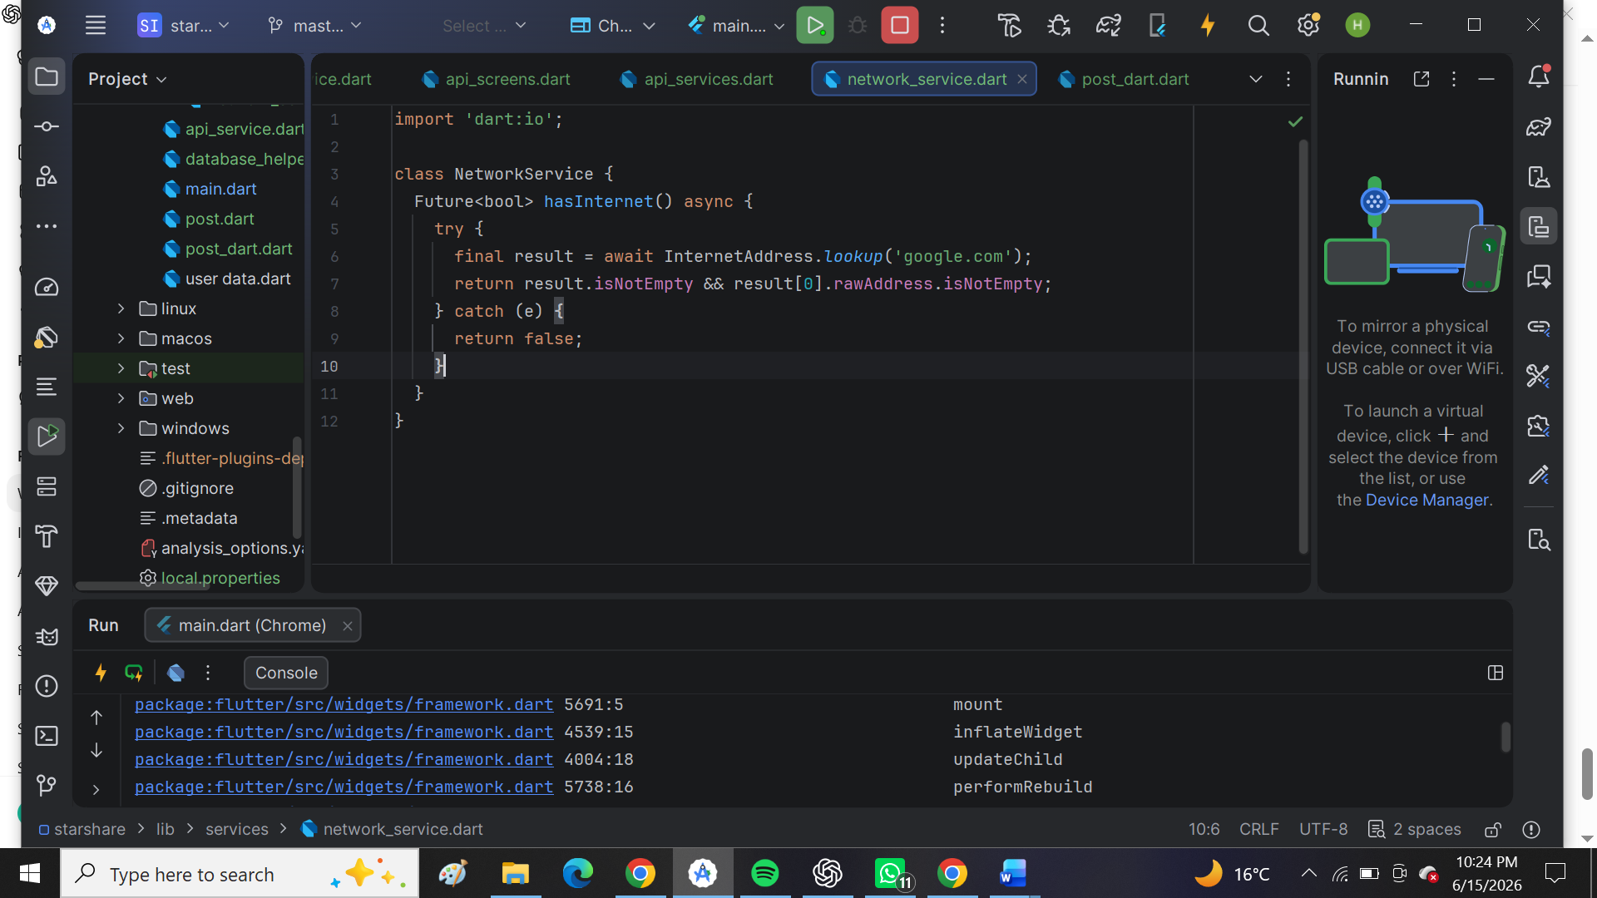
Why does my system (Starshare) require networking?
StarShare requires networking to upload, sync, and retrieve files and user data between devices and the server.

